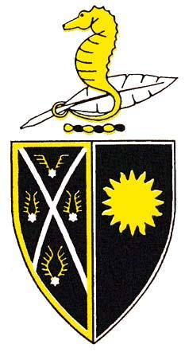
Sunnybrae Normal School
36 Sunnybrae Road. Hillcrest. Auckland 0627. NEW ZEALAND
Phone: (649) 443 5058 Fax: (649) 443 5257

Email: office@sunnybrae.school.nz

8th November 2018

Dear Parents/Caregivers

We wanted to give you an update on the stomach bug that has affected our school over the past few days. As you will be aware, we have been working closely with the Auckland Regional Public Health Services to minimise the spread of the illness. Our school’s cleaning service and caretaker have worked very hard to ensure all relevant surfaces are sanitised in accordance with the Auckland Regional Health Services guidelines and will continue these additional stringent procedures as required.

We are aware of some uncertainty around when children can return to school. The Auckland
Regional Public Health Services have advised that children need to be free from symptoms for 48 hours before returning to school. Therefore, those children who are still symptom-free can attend school tomorrow (Friday), while those who exhibited symptoms on Wednesday 7 November or today will need to remain off school for the remainder of the week. However, if there is any doubt that your child may be unwell, we ask you to err on the side of caution by keeping them home for an additional day for their sake and the sake of other children and staff.

We are hopeful that the weekend break and Monday’s non-teaching day (due to primary schoolstrike action) will further reduce any risk of illness. We really appreciate your support with this and trust that next week will see all of our children and staff at the school and feeling healthy.

As per the earlier email, the sausage sizzle has been cancelled for tomorrow.

Our teachers will ensure that this does not have any impact on our teaching and learning
programmes and please don’t hesitate to contact us if you have any questions, feedback or
concerns about this matter.

Thanks for your support over the past few days.

Kind regards

Lorene Hurd, Principal
Terry Sugrue, Board Chair

